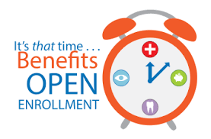

Dates to Know for This Year’s

Open Enrollment Season

Enrollment for January 1, 2019 benefits begins on October 15, 2018 and ends on November 4, 2018.

Be sure to review your enrollment materials and learn about your benefit options.

- What’s changing?
- What do YOU need to do?
- Make sure to participate in Open Enrollment!

